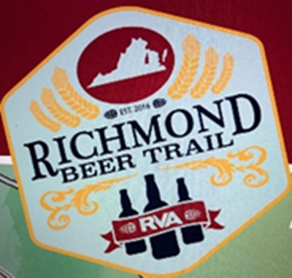
RSC’s Summer 1K Brew Thru
JOIN YOUR FELLOW SKI CLUB FRIENDS!
In Scott’s Addition
Sunday, August 22, 2021
Hosted by: Linda Neal, Betty Anne Harsh & Floyd Backley

RSVP required – please RSVP no later than 8/20/2021
Contact Linda Neal: activities@richmondskiclub.org or 804-350-3589
Meet at Three Notch’d Brewing at 1:30 PM. (2930 W. Broad Street, Richmond, VA). See Linda to obtain your Race Bib and Course Map.
START TIME: 2pm
Move at your own pace….see Linda or Betty Anne to obtain stamps for your bib!
Afterwards we will meet at 5:30 at the Roof Top of Hof Garden located at 2818 Broad Street, Richmond, VA, 23230.
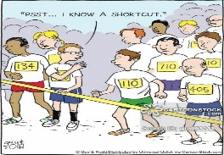
This Photo by Unknown Author is licensed under CC BY-NC-ND

